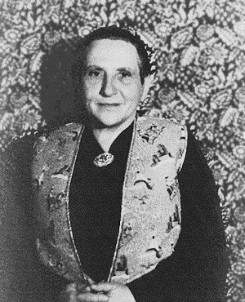
The Lost Generation
The ‘Lost Generation’ is a group of expatriate American writers who came of age during World War I and subsequently became prominent literary figures following the war. The term can also be used to refer to the whole of the post-World War I generation. The term was coined by Gertrude Stein in a comment to Ernest Hemingway in which she declared, ‘You are all a lost generation’. Hemingway subsequently used this phrase as an epigraph to his novel The Sun Also Rises (1926) which is often seen as emblematic of the lost generation’s literary tradition. This generation was ‘lost’ because of the alienation they felt for American culture and the fact that the values they had grown up with no longer functioned in a post-World War I world. The group of writers associated with the Lost Generation includes Ernest Hemingway, F. Scott Fitzgerald, John Dos Passos, e.e. cummings, Sherwood Anderson, Malcolm Cowley, Gertrude Stein, and Djuna Barnes.

Further Reading:
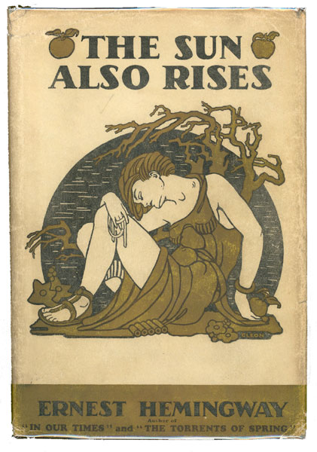
Cowley, Malcolm (1951). Exile’s Return. New York: Viking Press.

Cowley, Malcolm (1973). A Second Flowering: Works and Days of the Lost Generation. New York: Viking Press.

Hemingway, Ernest (1964). A Moveable Feast. New York: Scribner’s.

Dolan, Marc (1996). Modern Lives: A Cultural Re-Reading of ‘The Lost Generation’. West Lafayette, IN: Purdue University Press.

Monk, Craig (2008). Writing the Lost Generation: Expatriate Autobiography and American Modernism. Iowa City, IA: University of Iowa Press.

-Adam R. McKee

Image URL:
http://go.galegroup.com.proxy.lib.fsu.edu/ps/i.do?id=GALE%7CRN1450000488&v=2.1&u=tall85761&it=r&p=LitRC&sw=w

